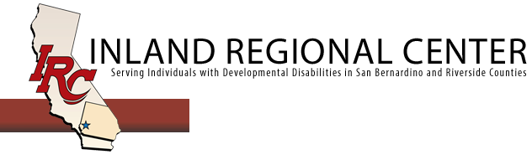
Paid Internship Program
- The Paid Internship Program is an incentive work program, funded by Inland Regional Center (IRC) to give employers the opportunity to place a pre-screened individual into their company, train, and assess with the hope to lead to full or part-time paid employment in the same job.

- The Paid Internship Program is available for individuals 18 years of age and above. This program is targeted to our adult population to allow them to develop job skills and training they may not have or have not been given the opportunity to achieve otherwise.

- Your business provides a minimum wage, or better paying position to an intern and Inland Regional Center funds the costs of the wages, worker’s compensation and any additional expenses. These wages are paid directly through a Financial Management Service (FMS) that acts as the Employer on record. IRC reimburses the FMS for all expenses. Therefore, no cost to the business.

- There is no minimum or maximum hour requirement. However, the maximum funding for payment of an internship is $10,400 per year, per individual. The internship ends once the $10,400 has been exhausted, or if the one year comes to an end, or if the intern or employer decide to terminate the internship. An employer can choose to and is encouraged to hire the intern directly prior to an internship ending.

- Employment success stories will have the opportunity to be spotlighted in Blog on IRC website. https://www.inlandrc.org/2018/06/27/disability-and-employment-irc-employment-specialists/

Please contact Beth Crane at (909) 890-3499 or Andrew Burdick at (909) 890-3120 with any questions

