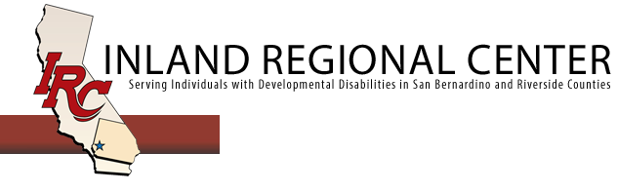
IRC Paid Internship Program (PIP) Exit Report for Vendors

Please complete and submit electronically via e-mail to Cityway, Candice Romero c.romero@citywaycedc.org Consumer Service Coordinator (CSC) and Employment Specialists, Beth Crane; bcrane@inlandrc.org or Krystal Spear kspear@inlandrc.org within 14 days of last day of internship.

Client Name:  UCI:  DOB: | Vendor Name:  Phone #:  Completed by (Name & Title):
Service Coordinator: | PIP Employer:
PIP Placement Start Date:  PIP Placement End Date: | Did the internship lead to a direct hire?  [ ] Yes, complete Part A  [ ] No, complete Part B
PART A
Date of Hire: | Hourly wage/Salary: | # of hours work per/week:
Would the client have achieved paid employment without the internship program?  [ ] Yes  [ ] No | Will the client continue to need job supports?  [ ] No  [ ] Yes | Benefits information Check all that apply:  [ ] Sick Leave [ ] Medical  [ ] Holiday [ ] Dental  [ ] Vacation [ ] Vision  [ ] Education/Training  [ ] Other:
Describe what was successful in achieving paid employment for the client:

PART B
What were the barriers to achieving successful paid employment for the client?

What did the employer like about the Paid Internship Program?
Will the employer consider other interns in the future? [ ] Yes [ ] No, Why?

IRC 2/2024

